**Installing McAfee Agent on Mac and Deploying Packages**

From Trellix ePolicy Orchestrator GoTo > System Tree > My Organization > Mac and from the Right hand select Deploy.

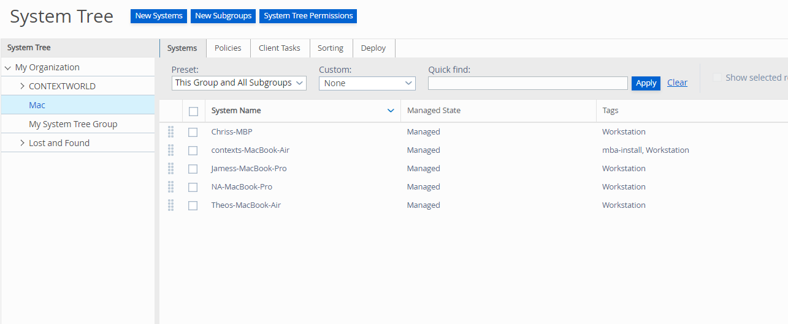

Under Deploy from the macOS field select Download Installer which will download McAfeesmartInstall.sh file

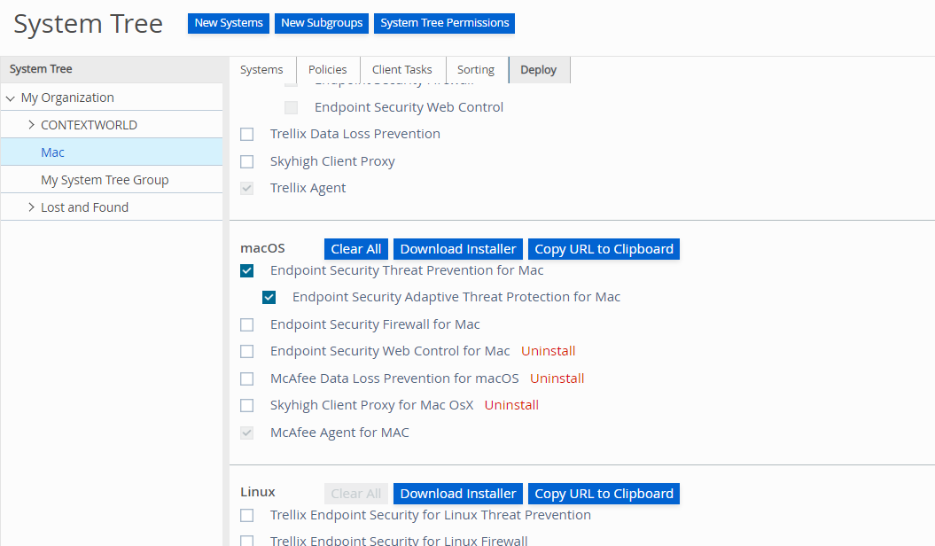

Now copy that McAfeesmartInstaller.sh file to the MacBook where we need to install McAfee Agent.

But before installing Agent make sure to check if Rosetta is installed on Mac. To check go to

**/Library/Apple/System/Library/Receipts**

Check if you find **com.apple.pkg.RosettaUpdateAuto.bom**

**Or**

You can check the following path  **/usr/libexec/rosetta**

if not install by using the following command.

**softwareupdate --install-rosetta**

After the installation now open Terminal and GoTo the location where you have stored McAfeeSamrtInstall.sh file and add execution permission to all.

Follow Below commands

**Chmod +x McAfeeSamrtInstall.sh**

**Sudo ./ McAfeeSamrtInstall.sh**

Once the McAfee installer has been opened, the installation will start automatically. The window will close on its own after downloading and installing the McAfee Agent. This may take a few minutes, depending on the speed of your computer and internet connection.

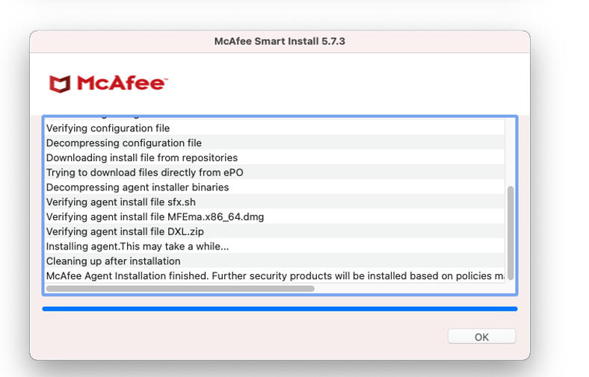

After the installation you can go to Trellix ePolicy Orchestrator and check whether you can see the name of the mac inside **System Tree > My Organisation > Mac**

If you can see the Mac Name which means Agent is successfully installed.

Now GoTo Product Deployment > Advanced Product Deployment > New Deployment > Give Name and select software packages as well as system and save. On the other side where Agent is installed on Mac we need to GoTo > System Settings > Privacy & Security > Full Disk Access and make this enable.

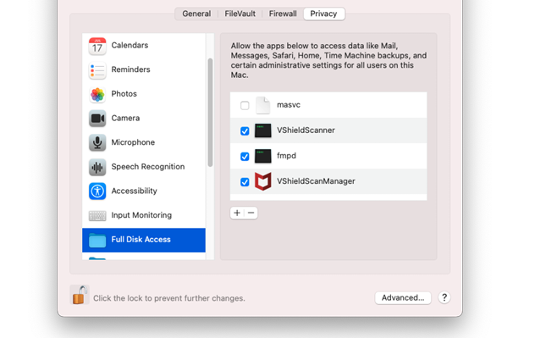

If you can’t see this you can click on the plus button below the applications list.

In the file selection dialog that opens on top of the System Preferences window, press Command-shift-G on your keyboard, then enter of the following paths

**/usr/local/McAfee/fmp/bin64**

**/usr/local/McAfee/AntiMalware**

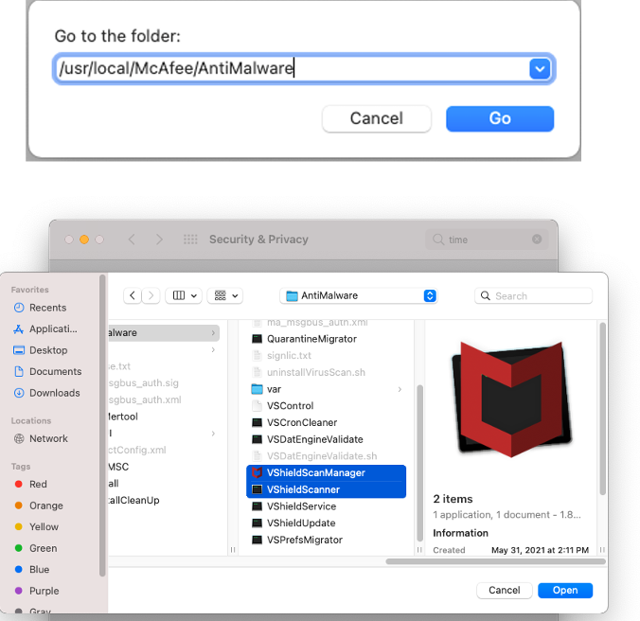

Once all three files have been added and the boxes next to them have been checked, the list of applications should look like the screenshot below. There may be other programs in the list as well, depending on what you have previously installed on your computer; those checkboxes can be left as they are.

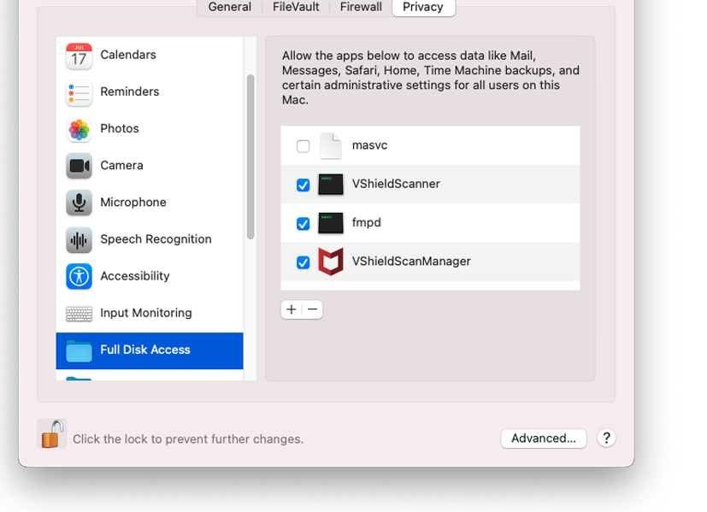

Now on the top you can see the McAfee Logo beside battery, Right click to open McAfee Agent Status Monitor.